Data Technician Workbook
Week 1: Excel

Name:
Course Date:
Table of contents
Day 1: Task 1 2
Day 2: Task 1 2
Day 2: Task 2 3
Day 2: Task 3 4
Day 3: Task 1 4
Day 3: Task 2 5
Dataset: 5
Step 1: Create a Pivot Table 5
Step 2: Use the SWITCH Function 5
Submission: 6
Day 3: Task 3 6
Day 4: Task 1 7
Course Notes 9
Additional Information 10

Day 1: Task 1

Please research and complete the boxes below on common laws and regulations that must be followed when working with customers' data, and use the below bulleted list to support your answers.

- What is it
- Why is it important
- Provide a real-world example of how you can follow it
- How does it impact working with data
- What could happen if you breached it

Data Protection Act | Laws and practices governing collection, storage and use of personal information. It is important to protect people’s privacy and make sure their information is used safely, it is accurate and only stored for longer it is necessary for legitimate purpose. As a real word example, a bank keeps customer’s information on their data base, but only staff with legitimate interest can access certain data. If other staff access data not relevant to their job, it can result in fines, reputational damage or even prison.
GDPR | It stands for General Data Protection Regulation and it defines people’s rights to access, erasure, rectify and object related to their stored data. As an example, I can contact my bank and request all data they hold related to my account activities and block my data to be used for marketing, for example. If the bank denies my request without a valid reason, they can be penalised under the law.
Freedom of Information Act | Under the Act 2000 the public can request information from public authorities, such as police, government, NHS. It promotes transparency and allows the public to know, for example, how their council spend the money from council tax. The organisation can deny it if there is a valid reason to do so, but they should explain the reasons. The person who made the request can challenge it. The organisation may suffer reputational damaged if they deny the request without a valid reason.

Day 2: Task 1

Please research and complete the following tasks within the retail-sales_dataset.xlsx document, and paste a print screen into the provided boxes below:

- In the sheet ‘retail_sales_dataset’, add all available data between columns A – H into a ‘table’ using Ctrl+T. Then name the table.
- Using the ‘filter’ function, filter ‘Age’ from ‘largest to smallest’
- Using the ‘SUM’ function, show me the commission total in cell ‘P10’
- Using the ‘AVERAGE’ function, show me the average commission in cell ‘P11’

Print screen 1 | 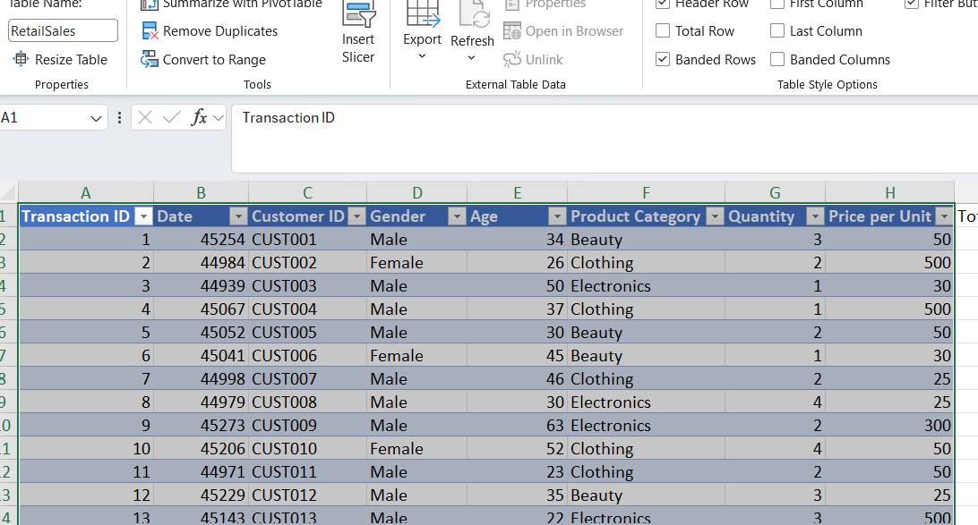
Print screen 2 | 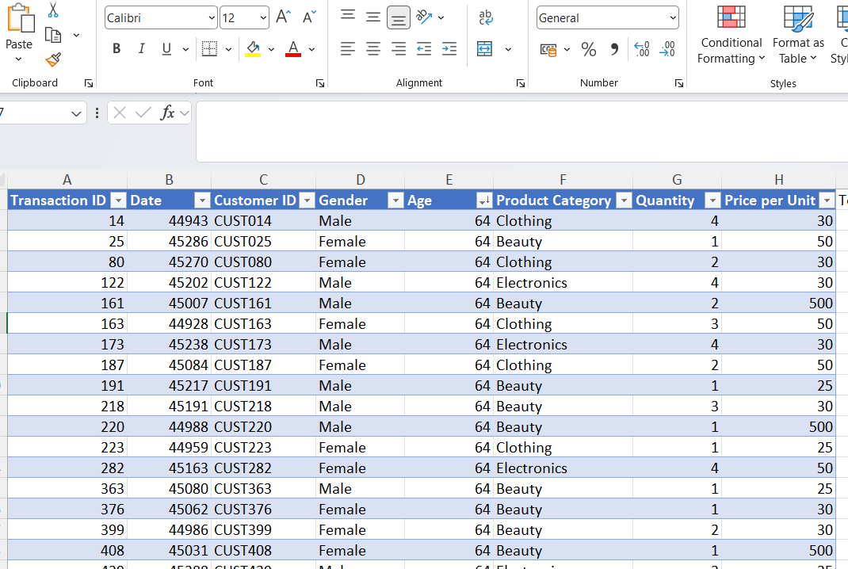
Print screen 3 | 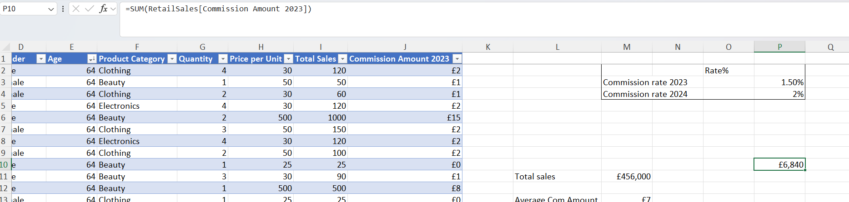
Print screen 4 | 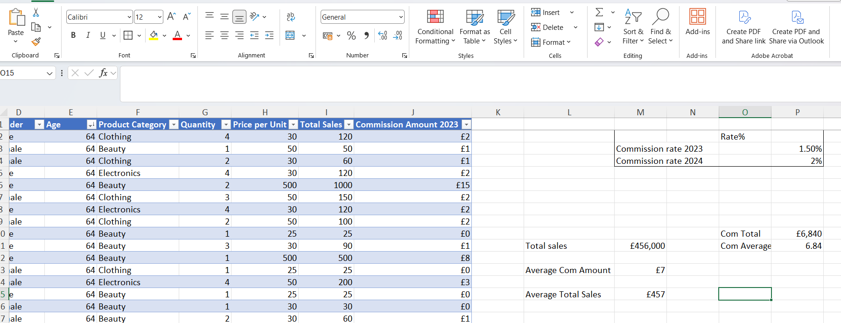

Day 2: Task 2

Please research and complete the following tasks within the document, and paste print screens into the provided box below:

Use the Student grades table provided by the tutor,

Convert the table to an Excel table. (Ctrl +T)

Student name | English | Mathematics | Science | Average | Highest score
Carol | 75 | 85 | 85
Khan | 85 | 75 | 80
Harry | 80 | 70 | 80
Sarah | 80 | 70 | 80
John | 65 | 80 | 70
Linda | 90 | 50 | 70
Edward | 55 | 80 | 60
Mary | 55 | 70 | 65
Thomas | 55 | 30 | 65

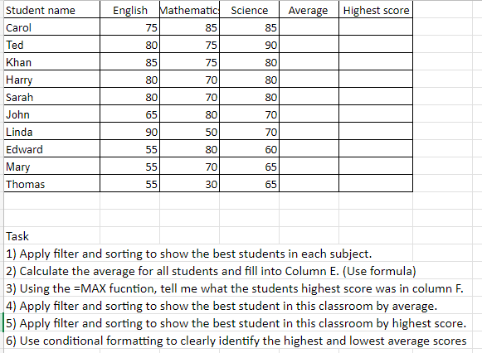

Print screen 1 | 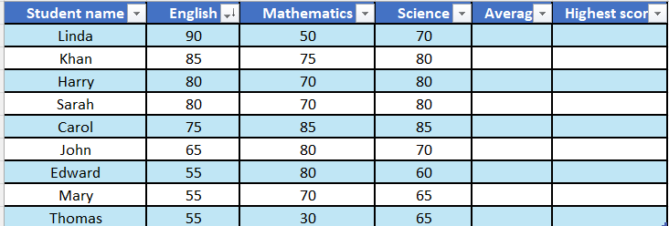  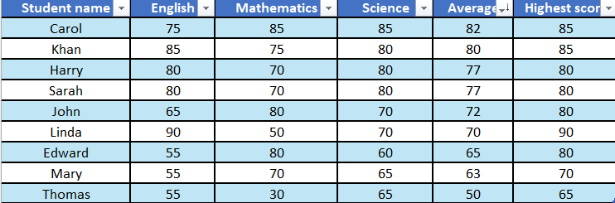  I have applied the filter as requested on question ‘a’ for all subjects. The print screen above shows it applied to subject Science.  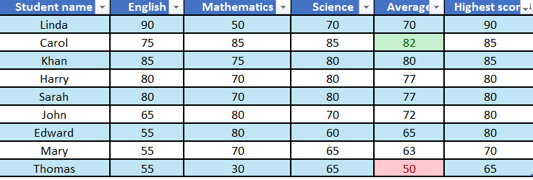

Day 2: Task 3

Using the skills developed today, have some fun with the data set you have imported. Paste your work below and enjoy!

Print screen 1

Day 3: Task 1

Dataset:. and, Day_3_Task_1_Bike_Sales_Pivot_Lab.xlsx
Lab instructions: Lab pivot table use for task 1 instructions

Make a copy of the dataset. Use the copy.

Convert to Excel Table (Ctrl +T)

Follow the lab instructions. Do not worry if you do not complete the lab; just working with data and playing with the pivot table will be a good experience.

Note:
Under refine the pivot table:
To mask 0's.
Click the pivot table
Click the Pivot Table Analyse tab on the menu bar.
Options > options > layout and format> In the field for empty cells, select the checkbox and enter 0 (zero). Ok.

And for the reflection questions, please do them in your workbook, not in the lab.

Please paste your final pivot table below and complete the reflection questions:

Print screen 1 | 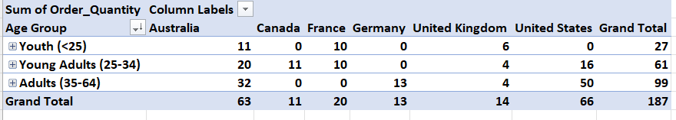
In which markets does Germany have customers? | Germany only has customers on the age group 35-64.
What country has sales in all markets? | Australia and United Kingdom have sales in all markets.
What are the most profitable markets by country, age group, and gender? | It is not possible to determine by the pivot table which market is more profitable as the data has been summarized according to order quantity, age group and gender. However, in number of sales United Stats leads the group of countries in the table, with 66 units sold. The age group 35-60 is the one most buying bikes, 99 units, and sales by gender is led by female group.
Any other findings? | United States appears with 3 different spellings. I replaced the ones with extra space with the correct spelling. Canada only have customer in the group young adults (25-34), and United States doesn’t have customers in the age group <25.

Day 3: Task 2

The dataset below tracks the sales performance of different products in various counties in England. Please paste the dataset into a blank Excel workbook. Your task is to:
- Create a Pivot Table to summarise the data by county and product.
- Use the SWITCH function to categorise products based on their sales volume.
See instructions below.

The dataset can be found in the last workbook you used.

County | Product | Sales Volume
Yorkshire | Laptops | 500
Yorkshire | Smartphones | 200
Cornwall | Laptops | 700
Cornwall | Printers | 400
Lancashire | Smartphones | 150
Lancashire | Laptops | 600
Essex | Printers | 800
Essex | Smartphones | 300
Durham | Laptops | 250
Durham | Printers | 300
Greater Manchester | Smartphones | 600
Greater Manchester | Laptops | 400

Dataset:

Step 1: Create a Pivot Table
- Select the dataset (columns A to C).
- Insert a Pivot Table to summarise the data by County in the rows and Products in the columns. Use Sales Volume as the value to be summarised.

Step 2: Use the SWITCH Function
In a new column next to your data, use the SWITCH function to categorise products based on Sales Volume as follows:
For sales greater than 600: "High"
For sales between 300 and 600: "Medium"
For sales less than 300: "Low"

SWITCH Function Example:
=SWITCH(TRUE, C2 > 600, "High", C2 >= 300, "Medium", "Low")

- Apply this formula to each row, and check if the products are categorised correctly.
- In ‘Sales Volume’, you need to remove the space after each amount – hidden spaces
- Confirm the data type is numerical

Submission:
- A completed Pivot Table summarising sales by county and product.
- A new column in the dataset categorising products by sales volume using the SWITCH function.
  - Please paste your completed work below

Print screen 1 | 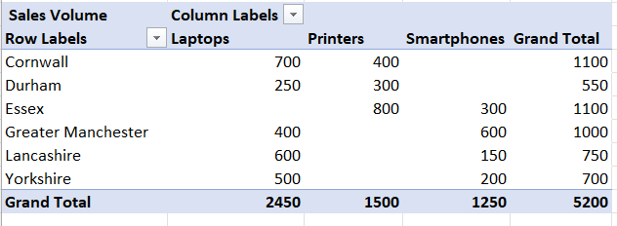  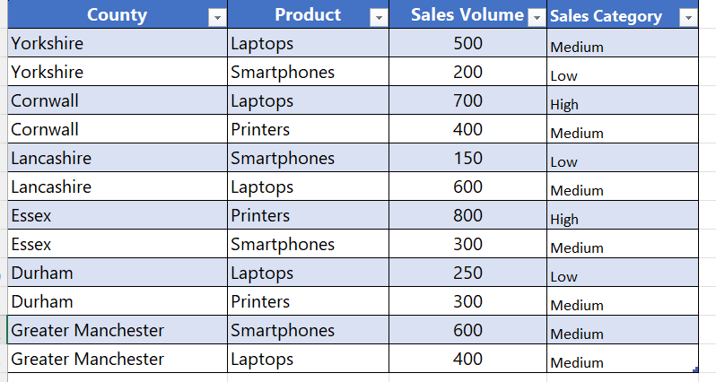

Day 3: Task 3

Please download the dataset ‘Day_3_Task_3_Bike_Sales_Visualisations_Lab.xlsx’.
Also, download the lab instructions.

Pivot tables are already created; you will need to create the pivot charts.

Follow the lab instructions.

Do not worry if you do not complete the lab; just working with data and playing with the charts will be a good experience.

Please paste your results below:

Print screen 1

Day 4: Task 1

You have been asked to deliver your analysis findings to the board of directors. Within your analysis, you have identified that customers are leaving your company at the 12-month point, which is typically when they receive their renewal price.

Choose a business or organisation to focus your findings on.

Conduct research and complete the following questions:

As in all work situations, you can use AI Gen tools for research: it needs to be in British English, check spelling, grammar and maths; and written in your voice, not copied directly from the tool.

How would you prepare for the delivery? | I have based my research on L&G Home Insurance.  Before delivering my analysis findings, I would review them to ensure they are accurate, clearly evidencing the important points and that it the customer’s requirements.  I would also decide on the best way to present my findings, making sure they are appropriate for the audience and that any written information is clear, concise and has no spelling mistakes or grammatical errors.
What tools would you use for the delivery? | I would use Excel to organise and analyse the data, creating tables, Pivot tables to summarize them, including charts to represent key information in a more accessible and clear way.  To present visual information and structure the presentation, I would use Power Point. If presenting it remotely, I could use a video conferencing tool, such as Teams or Zoom.
What is prospecting, and why would you complete this before your delivery? | Prospecting is researching the audience to obtain relevant information to understand their priorities. In this scenario, I would research the board of directors at L&G, to understand their business priorities and what information would be more relevant to them.  This would help me tailor my presentation to the audience, focusing on the key findings and relevant recommendations.
Tell me the best practices for public speaking and providing updates to senior leaders | Crucially, making sure the presentation is tailored to the audience and ensure it meets the business requirements. When presenting to senior leaders, speaking clearly, being concise, using visual representation and avoiding unnecessary jargons or technical information is also important.  A good practice would be to prepare in advance for questions that may arise and allow time for discussion at some point during the presentation or at the end.
What will you show the board in your delivery? | I would show the Power Point presentation, alongside the Pivot tables and charts created in Excel, highlighting customer cancelations at the renewal stage, percentual of customer retentions and may include some what-if scenarios, depending on the data available and on the requirements, to support business decision-making.
How will you articulate the changes that are needed? | I would keep the presentation concise and objective, demonstrating the trends I identified though my analysis in a clear way and explain how my findings could support L&G decision making.
Provide a list of online resources and videos that will support your preparation for public speaking | Those resources are available online, including videos.  TED talks – between other strategies, the 18-minutes rule is recommended.  Microsoft Support –  https://support.microsoft.com/en-us/powerpoint/  Practical exercises to learn and improve on Office 365 apps, including PP presentations.  Toastmaster International – https://www.toastmasters.org/  Non- profit organisation that teaches public speaking.  Some helpful YouTube channels  Kevin Stratvert – AI, productive tools, step-by-step tutorials for Excel.  Vinh Giang – communication sills teacher
Evaluate tools that provide visualisation.  Tell me what they are.  Tell me what you would choose when delivering your presentation and why | Some of the tools that provide visualisation are: Excel, Power Point, Power BI and Tableau.  I am using Power Point and Excel on this presentation to the board of Directors of L&G. Power Point is a great tool to structure the presentation and to provide visual representation, helping to keep the presentation on the correct flow as it progresses.  Excel will aid the analysis, organisation and the representation of the data and a clear and intuitive way.

Course Notes

It is recommended to take notes from the course, use the space below to do so.

Additional Information

We have included a range of additional links to further resources and information that you may find useful, these can be found within your revision guide.

END OF WORKBOOK

Please check through your work thoroughly before submitting and update the table of contents if required.

Please send your completed work booklet to your trainer.

